Run the SSH key generation command

**ssh-keygen -t ed25519 -C "suryaprakashnaidu21083@gmail.com"**

**ssh-keygen -t rsa -b 2048 -C "your_email@example.com"**

step- 2:

**eval "$(ssh-agent -s)"**

step-3:

**ssh-add ~/.ssh/id_ed25519**

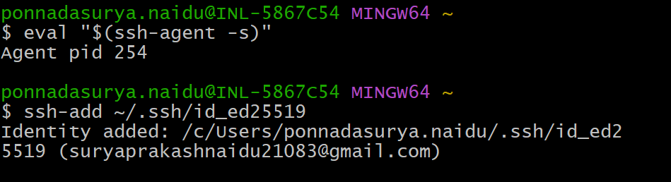

Step-4:

**cat ~/.ssh/id_rsa.pub**

you will get a public key save it in the github SSH keys